“To Health, Long Life & Pleasures! “ Show
Hosted by Lillian Zeltser

L'Chaim Shticks
(Functional Food Recipe)
Here is my grandma’s secret survival recipe, called ‘L’Haim Shticks’. It had been in our family for generations and had helped my ancestors to survive the famine, an earthquake and many hardships of World Wars I & II, Revolutions, Pogroms and the Communist Era in the former USSR.
Ingredients:
3 kg Any animal or poultry flesh (with min. 30% fat content)
1 tablespoon Black pepper ground
2 tablespoons Paprika powder
3 tablespoons Sea salt
3 tablespoons Raw Honey

Cummin seeds 3 tablespoons ground
Caraway Seeds 3 tablespoons ground
Preparations & Storage:
- Preheat the oven to 120-130C
- Mince the meat
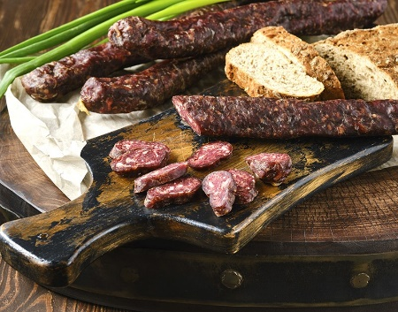
- Except for caraway seeds, thoroughly mix in all the rest of the ingredients and mince the meat again
- Divide the mince into six parts and form six thumb-tick rolls & dust them with ground caraway seeds
- Place shticks on the baking tray lined with baking paper and bake for 4 hours or until the sticks become dark brown and harden
- Leave to rest at room temperature until cold
- Wrap each roll in parchment paper and store it in a cool dry place. My grandma used to keep her shticks in a cotton sack suspended from the ceiling in her basement.
- Replace every season of the year. According to tradition, the old shticks should be replaced with new ones, every first day of winter, spring, summer and autumn. The old shticks make the perfect nutritious protein snack or can be added to soups, casseroles, pies, and other dishes.

