“To Health, Long Life & Pleasures! “ Show
Hosted by Lillian Zeltser

“Mama Rosa’s Hypnotic Stew”

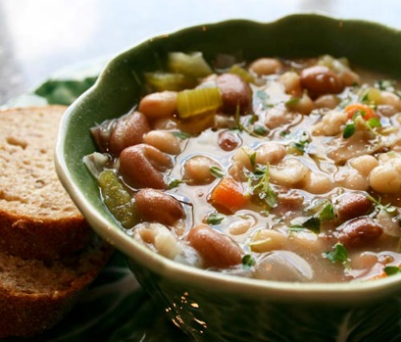
There is a strong connection between what a person eats and how they feel. Some foods can help you relax, increase your sensuality or decrease the level of the stress hormone cortisol in your body that has been raised by some sort of conflict or pressure. The below Italian stew recipe does exactly that! So, when you feel next time blue, resort to Mama Rosa’s De-stressing Tuscany Stew which is such an easy one-pot cheap and straightforward dinner. It is packed with flavours of Italy, sunshine, and happiness, as it contains everything to make you feel great from the inside out.

Ingredients:
- 2-3 tablespoons of olive oil
- 1 brown onion finely chopped
- 3 cloves of garlic, crushed
- 1 large carrot, chopped
- 2 sticks of celery, chopped
- 1 red pepper, sliced
- 400 g tin of borlotti beans, drained & rinsed
- 400 g tin of cannellini beans, drained & rinsed
- 3 ripened tomatoes (diced)
- 250 ml water
- 1 teaspoon of dried oregano (and/or dried thyme)
- 1 tablespoon of dried artemisia absinthium (Wormwood)
- 100g of almond kernels
- 100g of pistachio kernels
- 1 tablespoon of balsamic vinegar (optional)
- handful of baby spinach and arugula

Instructions:
- Heat the olive oil in a casserole dish and gently fry the onion for 3-4 minutes or until starting to soften.
- Add to the pot of carrot, celery and garlic and cook for a further 2-3 minutes, then add sliced red pepper and diced tomatoes. Let it cook for 5 more minutes.
- Add water, beans, oregano, and balsamic vinegar, and season with salt and black pepper to taste then cover with a lid and simmer for 20 minutes. Remove the lid and simmer for a further 10 minutes or until the sauce has reduced and is thick and glossy.
- Stir almonds and pistachios through the stew for the last two minutes of cooking. Taste and adjust seasoning if required. Serve decorated with baby spinach and arugula with and fresh slice of sourdough bread.
Enjoy this wholesome dish that will make you feel comfortable, and happier as if you are looked after by Mama Rosa from beautiful Tuscany.

